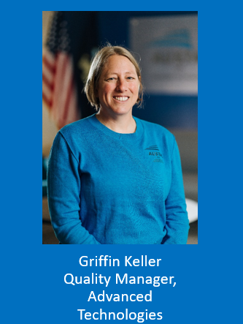

Griffin Keller leads the development and implementation of quality system at Austal USA’s Advanced Technologies division and also the U.S. Navy Additive Manufacturing (AM) Center of Excellence. Her expertise spans several disciplines, including gas turbine service and repair, medical device design and development, manufacturing, supplier management and development, quality, and regulatory management. Griffin oversees the supplier engagement program for the Navy-funded AMCoE, which is working to accelerate the introduction of AM into the maritime industrial base by assisting suppliers in navigating technical and quality requirements. Griffin earned a M.S (2008) and a B.S. in mechanical systems engineering (2001), with a focus on biomechanics, both from the University of Central Florida.

